Recipe Title
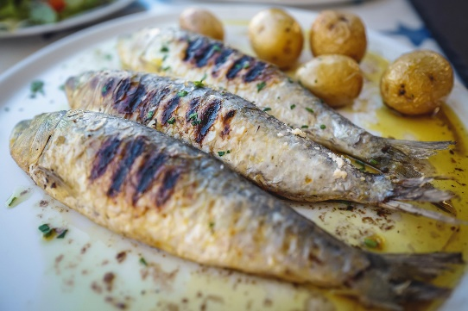
Replace this with a brief description of the final product. Change the picture on the right to your own dish. (Right click -> change picture)
Ingredients
Amount Ingredient
Amount Ingredient
Amount Ingredient

Directions
Type Recipe directions here

